Mishen Naidoo

ST10250201

INSY6112

Question 1

A NoSQL (Not Only SQL) database is one that stores, manages, and retrieves vast amounts of various, unstructured information. Unlike conventional relational databases, which utilize organized tables with defined schemas, NoSQL databases provide dynamic schema models, horizontal scalability, and lightning-fast data processing (MongoDB, 2024a). These databases are especially suitable for managing real-time applications like social media platforms, where data types change and scale constantly (Zhang and Zhang, n.d.).

Justification for Utilizing a NoSQL Database:

* Scalability - NoSQL databases allow for horizontal scaling through the addition of extra servers to divide the workload. This is critical for a social media network experiencing rapid data development (AWS, 2025).
* Flexibility in Data Structures - compared to relational databases, NoSQL supports storing a variety of data kinds, including text, photos, videos, and live streaming, without the need for established schemas (Atlan, 2023b).
* Real-Time Performance - Optimized for low latency and fast data processing, NoSQL databases provide real-time updates for social media feeds, alerts, and trending topics (Database, 2023b).

Types of data stored in NoSQL database:

1. User profiles

* NoSQL databases keep track of user profiles, which include usernames, email addresses, profile images, and other account-related details. NoSQL enables for the flexible storing of extra user characteristics without affecting the overall structure (MongoDB, 2024b).
* Following and followers’ lists are also recorded, making graph databases ideal for handling complicated user connections (Database, 2023b).
* Security settings, privacy restrictions, and account configurations are saved dynamically, enabling users to change them in real time.

2. Posts and Media

* Users can upload a variety of material on social media sites, such as text messages, photographs, videos, GIFs, live streaming, and virtual reality experiences. MongoDB, a document-based NoSQL database, is ideal for storing these many media kinds (MongoDB, 2024b).
* NoSQL databases store postings in adaptable JSON documents, which makes it simple to handle new media kinds without changing the database structure (GeeksForGeeks, 2024).

3. User Interactions

* Likes, comments, shares, views, and responses are all factors that impact social media engagement. These interactions create enormous amounts of real-time data that needs to be handled with minimum latency (Zhang and Zhang, n.d.).
* NoSQL databases are also used to store and handle notifications, ensuring that users are alerted to new comments, mentions, and direct messages on time.

4. Analytics Data:

* Real-time engagement statistics are essential for following trends, detecting viral content, and comprehending user behaviour. Social media networks must handle billions of interactions every day, rendering standard relational databases inadequate for such volumes (MongoDB, 2024a).

4 Types of NoSQL database types:

1. Document-Oriented Databases - These databases store data as flexible JSON-like documents, making them excellent for managing dynamic and unstructured material like articles, comments, and user profiles. MongoDB and CouchDB are examples of databases that efficiently index and query enormous quantities of user-generated material. The flexible schema architecture allows for new features to be added without large database changes (MongoDB, 2024b).

2. Key-Value Stores - These databases hold data as key-value sets, allowing for efficient caching and rapid lookups. These databases are designed to store session data, alerts, and real-time changes. The simplistic format allows for quick retrieval of user interactions, likes, and comments (AWS, 2025).

3. Column-Family Stores - These databases store and retrieve big datasets by organizing data into columns rather than rows. These databases are ideal for storing social media activity records on a distributed basis. They offer excellent reliability and resilience to errors, guaranteeing a seamless user experience all through peak traffic times (GeeksForGeeks, 2024).

4. Graph Databases - These databases manage relationships amongst entities, making them perfect for social networks. This is an efficient system for managing friend relationships, followers, and recommendations. Graph databases offer great performance for sophisticated connection queries, including common friends and influencer analysis (Database, 2023b).

3 V’s of Big Data:

1. Volume - The platform collects large volumes of data from millions of users every day, including posts, interactions, and media uploads.  
NoSQL databases are optimized for large-scale storage and reliable performance (Gillis and Robinson, 2021b).

2. Velocity - High-speed data generation from live interactions demands real-time analysis and adjustments. NoSQL databases provide faster data processing and retrieval, enhancing user experiences (Gillis and Robinson, 2021b).

3. Variety - The platform handles organized (user profiles), semi-structured (posts, comments), and unstructured (videos, photos) data. NoSQL enables effective storage and management of numerous information kinds using multiple data formats (Gillis and Robinson, 2021b).

Question 2

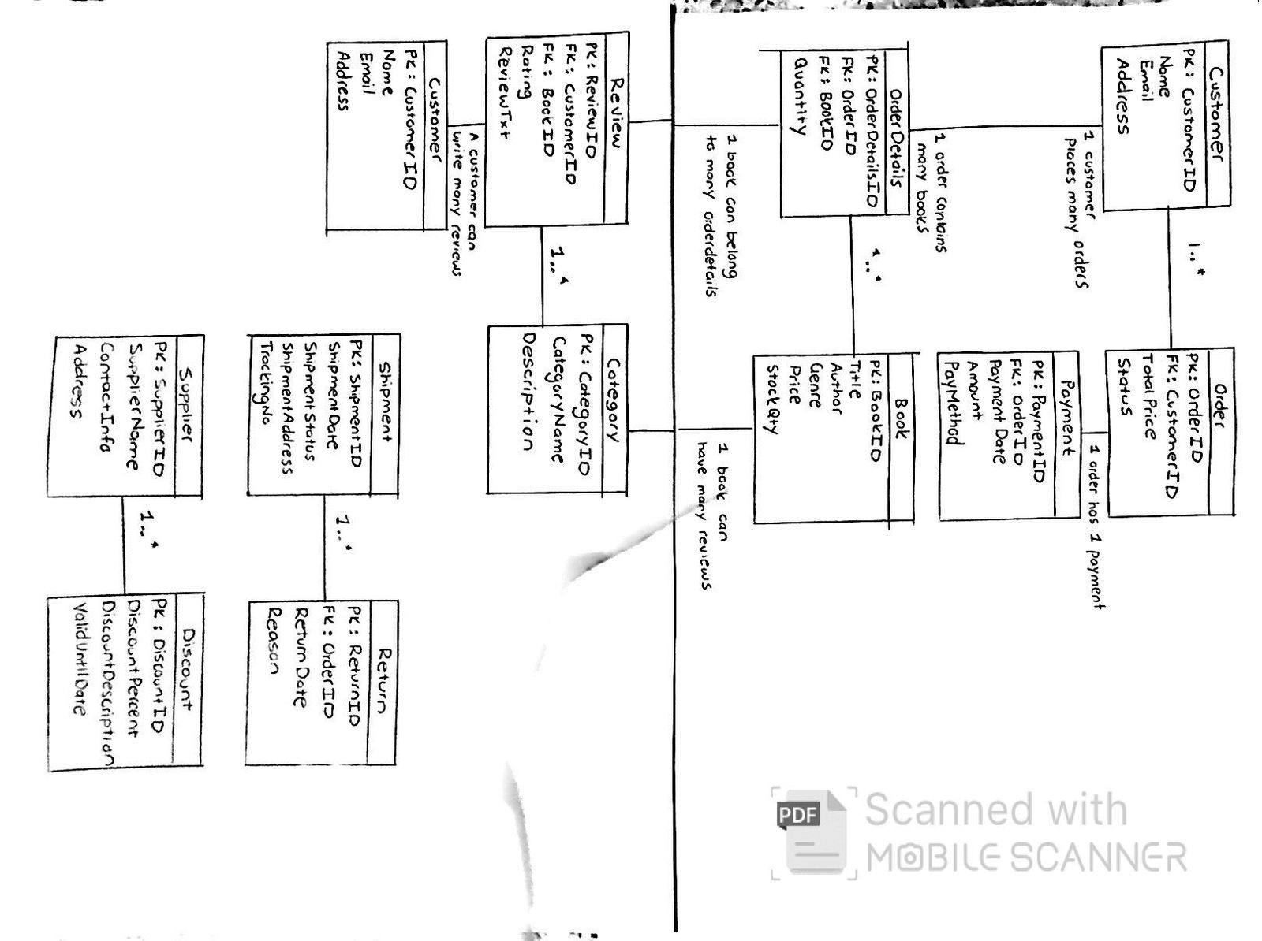

References

Whitepaper, *Types of nosql databases - choosing an AWS NoSQL database*, *aws*. Available at: <https://docs.aws.amazon.com/whitepapers/latest/choosing-an-aws-nosql-database/types-of-nosql-databases.html> (Accessed: 26 March 2025).

MongoDB. “What Is NoSQL? NoSQL Databases Explained.” *MongoDB*, 2024, [www.mongodb.com/resources/basics/databases/nosql-explained](http://www.mongodb.com/resources/basics/databases/nosql-explained). Accessed 26 Mar. 2025.

Zhang, Yixuan, and Chen Zhang. *Applications of NoSQL Database in Modern Social Media*.

Available at: <https://www.cs.rochester.edu/courses/261/fall2017/termpaper/submissions/12/Paper.pdf> Accessed 26 Mar. 2025.

Database, NebulaGraph. “How to Choose a Database for a Social Media App.” *Medium*, 1 Dec. 2023, [medium.com/@nebulagraph/how-to-choose-a-database-for-a-social-media-app-e8072a950c9c](mailto:medium.com/@nebulagraph/how-to-choose-a-database-for-a-social-media-app-e8072a950c9c).

Accessed 26 Mar. 2025.

Gillis, Alexander, and Scott Robinson. “The 5 V’s of Big Data.” *TechTarget*, Mar. 2021, [www.techtarget.com/searchdatamanagement/definition/5-Vs-of-big-data](http://www.techtarget.com/searchdatamanagement/definition/5-Vs-of-big-data). Accessed 26 Mar. 2025.

Dražena Gašpar, and Mirela Mabić. “NoSQL Databases as Social Networks Storage Systems.” *ENTRENOVA 2017 - ENTerprise REsearch InNOVAtion Conference*, 7 Sept. 2017, [www.researchgate.net/publication/319944521_NoSQL_Databases_as_Social_Networks_storage_systems](http://www.researchgate.net/publication/319944521_NoSQL_Databases_as_Social_Networks_storage_systems). Accessed 26 Mar. 2025.

MongoDB (2024). *Relational Vs. Non-Relational Databases*. [online] MongoDB. Available at: <https://www.mongodb.com/resources/compare/relational-vs-non-relational-databases>. Accessed 26 Mar. 2025.

‌

Atlan (2023). *Relational Database vs NoSQL: 15 Key Differences to Know!* [online] atlan.com. Available at: <https://atlan.com/relational-database-vs-nosql/>. Accessed 26 Mar. 2025.

GeeksForGeeks (2024). *How to Design Database for Social Media Platform*. [online] GeeksforGeeks. Available at: <https://www.geeksforgeeks.org/how-to-design-database-for-social-media-platform/>.

‌

‌